Modern Artificial Intelligence: History, Challenges, Ethics

B.D. Hoskins, NRC Postdoctoral Fellow
NIST, Gaithersburg, MD 20899, USA
brian.hoskins@nist.gov

From image recognition, natural language processing, self-driving cars, and beyond, modern Artificial Intelligence has begun to reshape many facets of life. Astonishingly however, the underlying mathematics behind modern neuromorphic networks has been with us for decades, and only recently have advances in computer hardware engineering enabled the proliferation of applications we see today.

In this talk, I briefly present the history of some of the most important ideas in neuromorphic computing and describe what makes AI work. Moving into modern times, I discuss the causes of the recent and rapid expansion of AI and describe how limits in modern computation could quickly put the brakes on its continuing expansion. The approaches that researchers around the world are working to deal with these new challenges includes some of my personal work.

Finally, I will look at the enormous impacts AI can have on society, and the ethical challenges it poses. Already, scholars and policy makers are debating and proposing new ideas about everything from teaching AI basic ethics, to reorganizing work as AI renders many jobs obsolete, to even reorganizing society around completely new values.

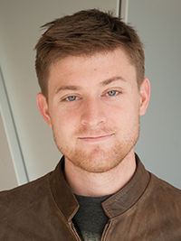
Brian D. Hoskins received a Ph.D. degree in Materials Science and Engineering from the University of California, Santa Barbara (UCSB) in 2016 as well as an M.S. and a B.S. in Materials Science and Engineering from Carnegie Mellon University in 2011. He is currently a National Research Council Postdoctoral Fellow at the National Institute of Standards and Technology’s Center for Nanoscale Science and Technology where he works with Dr. Jabez McClelland on characterizing resistive switches and other nanodevices for integration into novel computer architectures. For his doctoral research, he worked with Prof. Dmitri Strukov to investigate the deposition and characterization of resistive switches for neuromorphic networks.

